Layer Mask

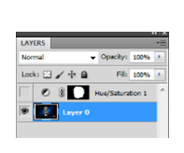
- File Open | Select an image that you would like to work on
- Ctrl + j | This will create a duplicate of the original image
- Ctrl + Shift + u | This will remove any colour from the original image and create a black and white copy
- Layer Mask | Create a layer mask and make sure that the new layer is highlighted
- Select black and white | Remember Black will reveal/ White will conceal colours in the new image
- Use the brush tool | Using the brush tool now you can reveal colours or remove colours from the new image that you duplicated
- Save | Using the File – Save As command save the new image as a .jpeg or .png in a location where you can find it
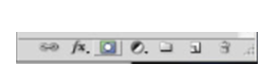

Layer Mask

